**How to create User Access in ERP Insurance**

**STEP 1:**

Log-in to ERP Insurance <https://42.79.1.58:8080>

Click Administration, see Figure 1.0

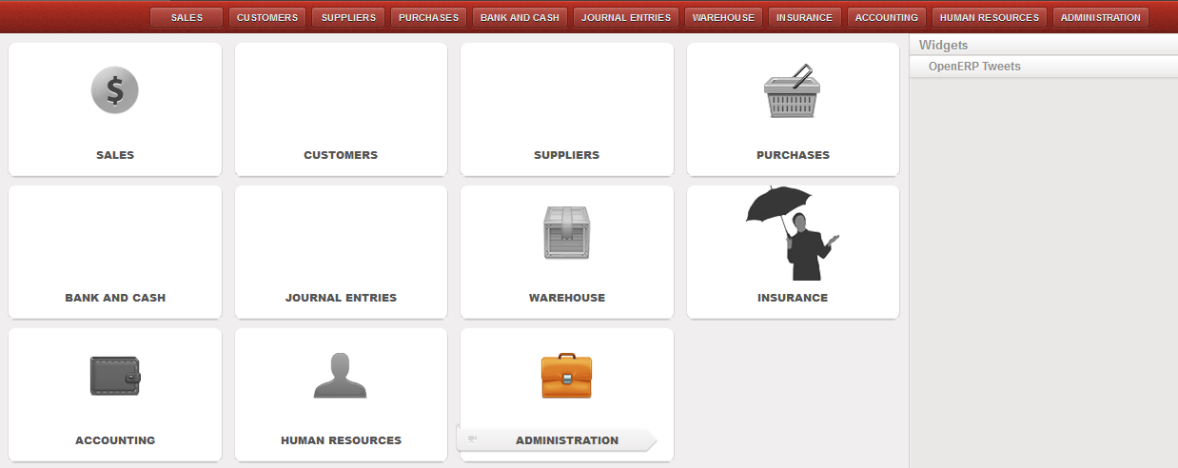**Figure 1.0**

**STEP 2:**

Select Users Menu and Click Users, see Figure 2.0

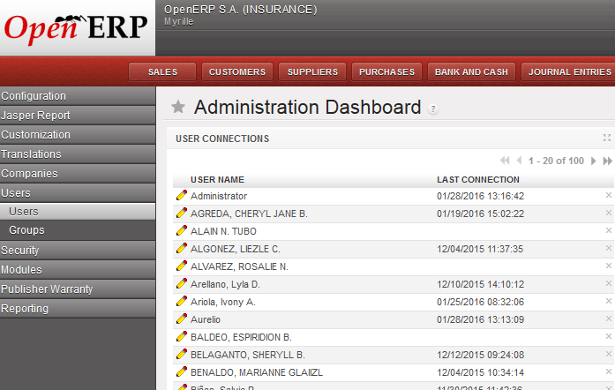 **Figure 2.0**

**STEP 3:**

Use SEARCH FIELDS to check if user access is already exist. Type the User Name and click SEARCH BUTTON.

To create new access, click the NEW BUTTON.

To Edit user access, click the Pencil icon. See Figure 3.0

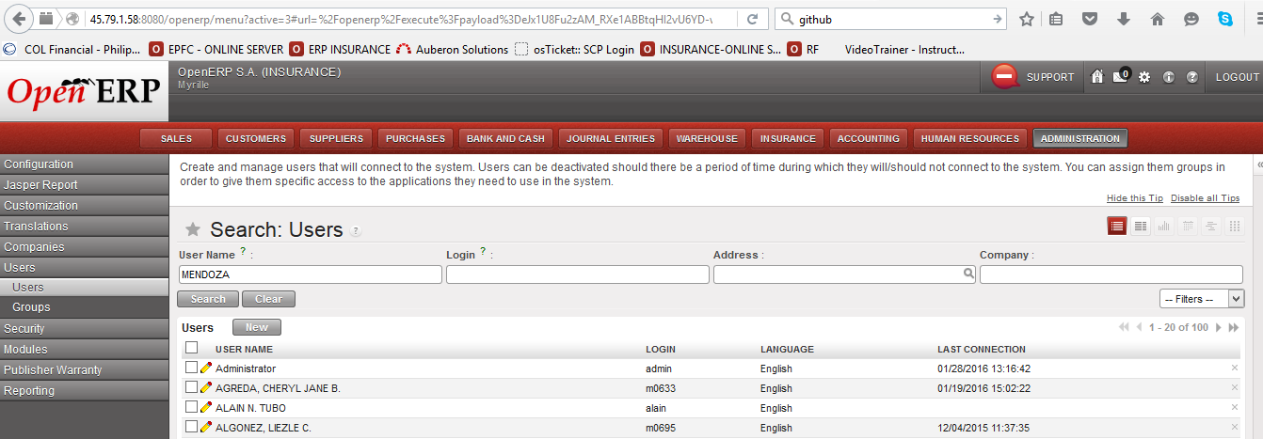**Figure 3.0**

**STEP 4:**

Select Sub-Agent of a user where he/she belongs by clicking the magnifying glass icon from SUB-AGENT Field.

Type the User Name with a format of Last Name, First Name Middle Initial in USER NAME Field.

Login should be the users’ company id number and Password is temporarily set also to users’ company id number.

INTERFACE Field should be set to Extended, see Figure 4.0

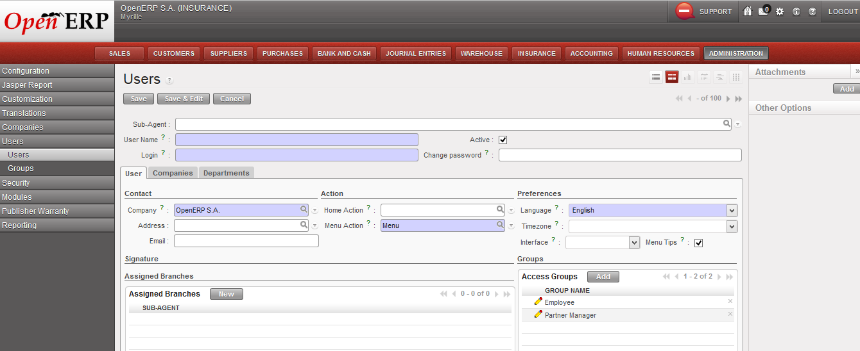**Figure 4.0**

In Assigned Branches, Click NEW Button to add the Sub-Agent if a user assigned into two or more Sub-Agent.

To Add Sub-Agent, click the magnifying glass icon to choose Sub-Agents. Click the Diskette icon to SAVE the selected Sub-Agent.

To Edit Sub-Agent, click the Pencil icon, see Figure 5.0

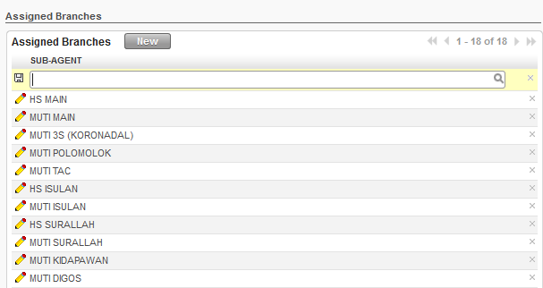**Figure 5.0**

In Access Groups, Click Add Button. Then tick the box for the appropriate user access. All user access should have an access group of INSURANCE USER. See Figure 6.0

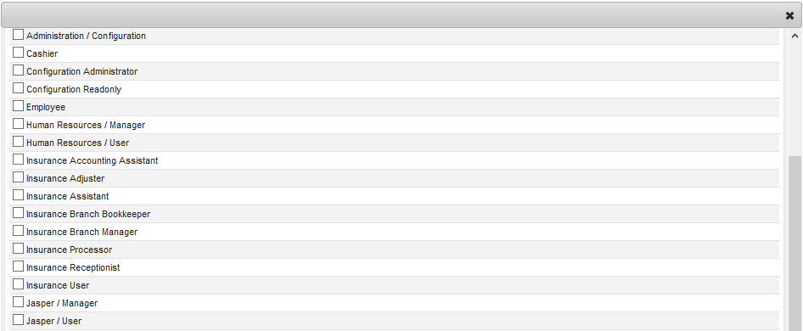**Figure 6.0**

Click SAVE Button after you done all the steps in STEP 4.